# **Data Visualisation and Communications assignment**

# **Final presentation on the Toastmaster Competency program**

# **Name: Galina Lopez**

# **Number: 10333429**

## Hand drawn data visualisation charting your progress.

## Tabulate the technical design decisions behind the char

## Craft your progress and reflections into a 5 minute speech and presentation.

***Title of chart****:* “Toast vs Master: My Toastmaster’s journey”

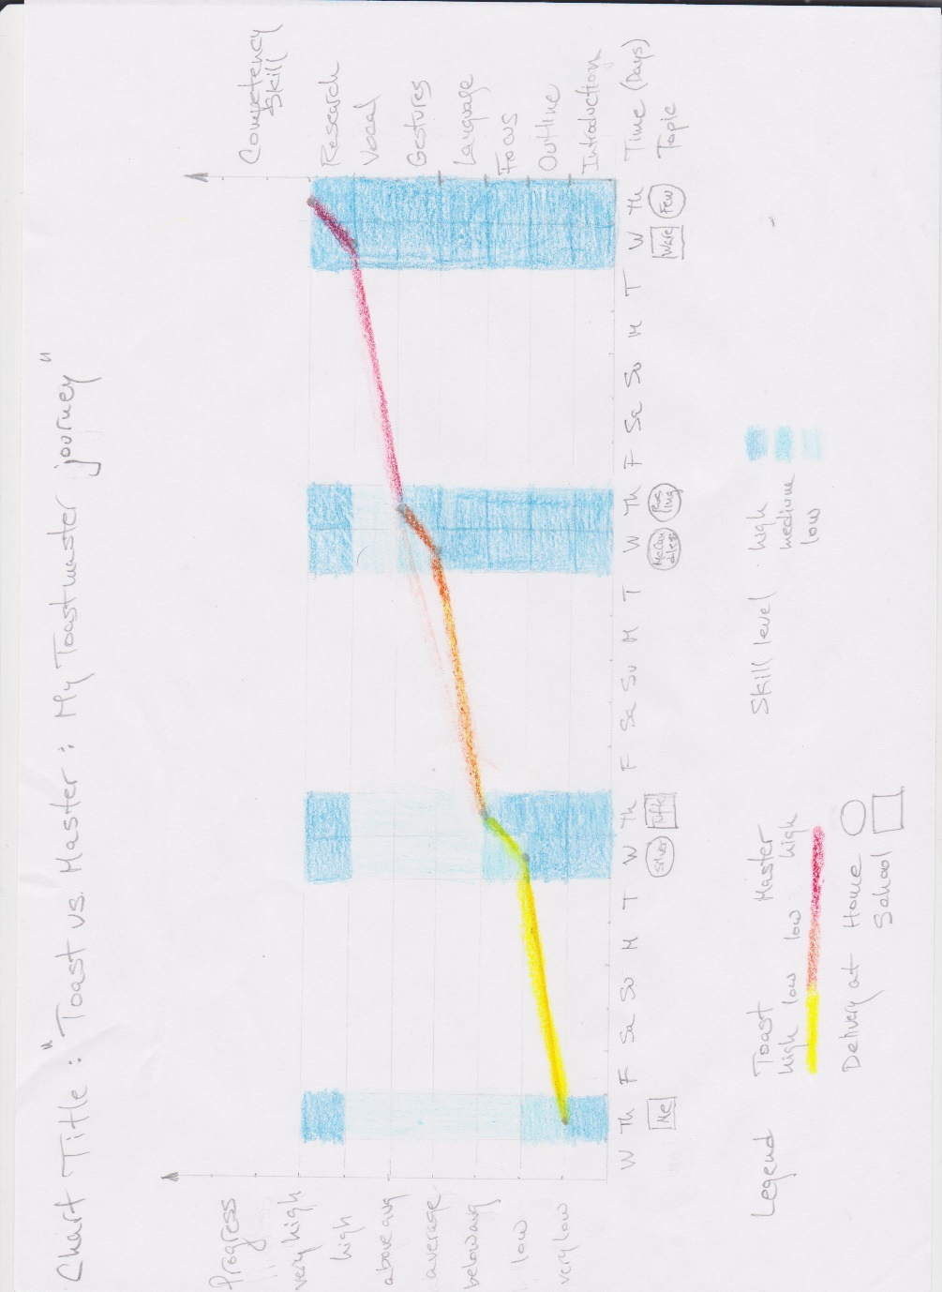

***Primary message the chart is intended to convey:*** My toastmaster journey in terms of my individual progress derived from my smart goals measurements by topic from very low to very high, humorously portrayed as from toast to master.

***Other messages (if any) the chart is intended to convey ranked in decreasing order of importance:***

My secondary message: My progress in terms of competency skills exercised on those topics.

Other messages: Length of the journey, day of the week speeches were given, where were they delivered.

***Type of chart:*** Dual axis line and heatmap chart.

Reasons: Line charts are most effective in conveying time series data like my individual progress and heatmaps are extremely effective in visualising comparisons between two categorical variables like competency skills and topics and encoding a third variable: skill level as the color saturation. I chose this combination of line and heatmap as this allowed for effectively encoding of many variables and still keeping simplicity, plus by using different shades of blue as background for my trend line it will pre attentively make it stand out even more. As it is a different color over shades of same blue. If I were to use different sizes of shapes my chart will look very busy and complicated so I opted for simplicity of my design to convey lots of information.

|  |  |  |  |  |  |
| --- | --- | --- | --- | --- | --- |
| **Variable** name | The **Data** **Type** of this variable | From data to display element. What are the visual encoding **options** typically recommended for this data type | Rank the **accuracy** of each of these options in decreasing order of importance. | State choice made and the **rationale** for the choice by **referencing** specific technical design principles to support decision. | Make an explicit link between the choice made for this variable and each of the **message** (s) the chart is intended to convey. |
|  | | | | | |
| Progress score  (very low, low, below avg average, above avg high, very high) | Categorical, Ordered or Ordinal | Position, Orientation, Size and Color Saturation are typically most effective for Categorical Ordered Data Type. | Accuracy: Position >Length >Angle/Slope>Color Saturation. | Y Position chosen as planar variables specifically position are the most accurate to represent data, especially ordered one. My ranking is based on Cleveland and McGill’s paper on visual encoding rankings. Also chose to give it the primary y-axis as it conveyed my primary message. Used pre attentive processing information stating people tend to read left to right.  Also following Stephen Few’s recommendations on effective graphics I chose to double encode this variable using dots marking their specific values in the trend line so as to emphasise their specific value and importance while keeping the chart simple. | This variable: Progress score is used to communicate the primary message: my individual progress based on my smart goals measurements over the topics that’s why I have chosen to encode it using the y position and chosen to give it the primary y-axis (left one) as pre attentively people always read from left to right and I wanted this to be my main message. |
| Topic  (Myself, Silver, Tufte, McCandless, Rosling, Ware, Few) | Categorical, Nominal. | Position, Orientation, Shape, Texture and Color Hue are typically most useful for categorical **nominal** data types. | Accuracy: Position >Angle/Slope>Area>Volume/Density>Color Hue. | X Position and  Images inside shapes, so using double encoding.  I chose to give this variable an x position encoding as position is the most accurate encoding for data plus by double encoding it inside the shapes I made sure their message was emphasised. My ranking is based on Cleveland and McGill’s paper on visual encoding rankings. | This variable: Topic is used to convey the primary, secondary and some minor messages in my chart that’s why I have chosen the x position to encode it. I want to convey all my progress against this variable topic so it serves as an effective x axis for both messages. |
| Competency Skill  (Introductory, Outline, Focus, Language Gestures, vocal, research) | Categorical, Nominal. | Position, Orientation, Shape, Texture and Color Hue are typically most useful for categorical **nominal** data types. | Accuracy: Position >Angle/Slope>Area>Volume/Density>Color Hue. | Y Position chosen as planar variables specifically position are the most accurate to represent data. My ranking is based on Cleveland and McGill’s paper on visual encoding rankings. Also chose to give it the secondary y-axis as it conveyed my secondary message. Used pre attentive processing information stating people tend to read left to right for this decision. | This variable: Competency Skill is used to communicate the secondary message: my progress in terms of technical skills used over the topics that’s why I have chosen to encode it using the y position and chosen to give it the secondary y-axis (right one) as pre attentively people always read from left to right and I wanted this to be my secondary not my main message. |
| Skill score  (low, medium, high) | Categorical, Ordered or Ordinal | Position, Orientation, Size and Color Saturation are typically most effective for Categorical Ordered Data Type. | Accuracy: Position >Length >Angle/Slope>Color Saturation. | Color Saturation chosen as it effectively encodes categorical ordered data. Moodle link on data types and appropriate visual encodings article used. Also used a lesser ranking encoding because it does not convey the main message so using size of shapes to convey its message would have complicated and distracted from the main one so I opted for simplicity. | This variable: Skill helps to communicate the secondary message: my progress in terms of technical skills used over the topics, more specifically it gives it a score from low, medium or high to give more detail of my progress, that’s why I have chosen to encode it using color saturation as it is a really effective encoding for categorical ordered data types. |
| Time  (M, T, W, Th, F, Sa, Su) | Categorical, Ordered or Ordinal | Position, Orientation, Size and Color Saturation are typically most effective for Categorical Ordered Data Type. | Accuracy: Position >Length >Angle/Slope>Color Saturation. | X Position chosen as planar variables specifically position are the most accurate to represent data, especially ordered one. My ranking is based on Cleveland and McGill’s paper on visual encoding rankings. Also chose to give it the x-axis as it encoding time as days of the week. Followed classic rules or conventions for how to encode time. | This variable: Time helps to convey all the messages in my chart that’s why I have chosen the x position to encode it. Plus time is by convention encoded in the x-axis when plotting time series data like the ones in these project. |
| Delivery place  (School, Home) | Categorical, Nominal. | Position, Orientation, Shape, Texture and Color Hue are typically most useful for categorical **nominal** data types. | Accuracy: Position >Angle/Slope>Area>Volume/Density>Color Hue. | Shape chosen as it effectively encodes categorical nominal data. Moodle link on data types and appropriate visual encodings article used. Also used a lesser ranking encoding because it does not convey the main message, I serves to draw more attention to the topic variable by proving the shapes framing the topic images. | This variable: Delivery place helps to convey one of the minor messages: place where speeches are delivered that’s why I have chosen a lesser ranked visual encoding to represent it: shape. I have chosen to fill those shapes with the images/names of my topics to keep my design simple while still conveying more information effectively. |
| Progress level  (Toast, Master) | Categorical, Nominal. | Position, Orientation, Shape, Texture and Color Hue are typically most useful for categorical **nominal** data types. | Accuracy: Position >Angle/Slope>Area>Volume/Density>Color Hue. | Color hue chosen as it effectively encodes categorical nominal data. Moodle link on data types and appropriate visual encodings article used. Also used a lesser ranking encoding because I needed it to emphasise the main message by drawing more attention to the progress trend line. Used pre attentive processing information article stating color is used effectively to draw the attention of people quickly. | This variable: Progress level helps to convey my primary message: specially the transition from toast to master, that’s why I have chosen a lesser ranked visual encoding to represent it: color hue. I have chosen to use a diverging color hue scale to encode it going from dark yellow: high toast to light yellow: low toast values to orange: even, to light red: low master to dark red: high master values. I have used it to color the line trend representing my individual progress so as to keep my design simple while still conveying more information. |
|  |  |  |  |  |  |
|  |  |  |  |  |  |